**Project Description**

**Car Rental Heterogenous System**

**Created by:**

**Michal Podgorni (267128)**

**Dragos Sirbu (266500)**

**Liviu Lesan (241737)**

**Gabriel Baciu (266828)**

**Supervisors:**

**Jakob Knop Rasmussen**

**Christian Flinker Sandbeck**

**Erland Ketil Larsen**

**Line Lindhardt Egsgaard**

**Jan Munch Pedersen**

**Ole Ildsgaard Hougaard**

**ICT Engineering**

**3rd Semester**

**20.09.2018**

Version: August, 2018

Template responsible: dans@via.dk

**Table of content**

1 Background description 1

2 Definition of purpose 2

3 Problem Statement 3

4 Delimitation 4

5 Choice of models and methods 5

6 Time schedule 6

7 Risk assessment 7

8 Sources of Information 8

Appendices

# Background description

Car Rental Systems are used commonly in many countries all around the world. They have become popular in recent years, when the globalization has developed, and travelling has gotten easier for all citizens. There are more than two millions of cars available just in The United States in approximately twenty thousands of places with revenue measured in millions, and the market is still growing.

Although renting a car is a popular option right now, it is still hardly accessible for some people. The goal of this project is to combine modern technology with old solutions. The target of this project are all people interested in renting a car, both young to old members of the society. Customers have various demands and that is why scope of this project predicts, providing them more than one way to book a car.

"If your business is not on the internet, then your business will be out of business" – Bill Gates, Founder of Microsoft (September 2011). A famous company from United Kingdom Europcar has gained more popularity because they chose to expand on the internet, then other companies followed. That is why big part of the project focuses on providing customers simple and quick online way of renting a car. Nevertheless, it is surprising how many rental companies approached were not very enthusiastic in turning their business to online although it brings a lot of bonuses. For this reason, many traditional features and operations are retained for the sake of older customers that are used to old ways.

# Definition of purpose

This rent-a-car project is trying to provide its clients with the most convenient and efficient way to rent a car.

# Problem Statement

The main objective of the project is providing customers a modern, convenient way of renting cars anywhere, at any time. Nowadays the process of renting a car can be complex and inconvenient. Clients must go through a rather complicated and time-consuming process. Therefore, car renting businesses that lack digital systems suffer significant loss in both work efficiency, since most of the work must be performed by humans, as well as consumer rate/popularity. If we ignore this problem, small businesses in the field can become susceptible to economic problems caused by advanced competition, thus ending bankrupt.

* **What is the best way to rent a car?**

To develop the most efficient and convenient renting system, booking options should be adjusted to the client’s situation, that is why customers will be able to rent a car online or in company’s office (employees are involved).

* **What of the client’s information should be stored in the system?**

All customers’ data needed for renting a car and making sure that the process is safe for both sides will be stored in the system.

* **Does it make sense for clients to create an account?**

While renting a car (online or at the office), clients have two options: they can either rent a car as a guest or they can sign in to the system/create an account. The second option might take more time but by implementing this feature company can build a long-term relationship with customers and show them that the company cares about them. There is also an option to add some amenities for trusted clients.

* **What is going to happen with canceled reservations?**

Reservations canceled in the first stage are erased from the system. If customer paid for reservation already, then the employee needs to take part in the process and approve money return, to make sure that everything is correct.

# Delimitation

* This project is going to cover a list of defined system requirements. Some points from the list will not be included in the project, but they can be a part of the future improvements.
* The project does not cover dedicated app for smartphones.
* The system will be written in English and this will be the only language supported in this project.
* There is no backup option for the system, which means that if any errors appear, stored data or renting progress might be lost.
* There are no facilities planned for clients registered in our system

# Choice of models and methods

|  |  |  |
| --- | --- | --- |
| **What ?** | **Why ?** | **Which?** |
| Various car rental options | Accessibility, offering clients the most convenient and efficient way to rent a car | The nature of the system (three tier architecture) |
| Relevant clients’ data in the system | Making the renting process safe for both sides, customers and the company | Proper database structure and database normalization |
| Security | To prevent any intruder of accessing information, in case of any errors | Network Protocols , Design patterns |
| Creating an account as a client | Shaping relationship with customers, possibility to extend functionality in the future | A better way to interact with the system |
| Canceled reservations | Predicting customers’ behaviors | Involving employees to the process |

The team responsible for the project consist of 4 people that are equally important, thus the workload is also divided (more or less) evenly among them. Every member is expected to spend around 250 hours on the project, most of the work will be done during team meetings thanks to that the whole team will be on the same page and the workflow will be better. For conducting and managing the project, SCRUM framework will be used.

# Time schedule

This project period starts in a week 34 and last until week 51 which is equal to approximately 17 weeks of work. The team is expected to spend around 1000 hours of work on the project (250 hours per team member).

Like it was mentioned, most of the work will be performed during team meetings, this way the team can make sure that all the tea members are actively participating and follow the plans and assumptions created at the beginning.

The SCRUM framework will be used to complete the project, meaning that the work will be planned in 5 sprints. The team will start with system description, requirements, product backlog and sprints planning. During each sprint the team will design, implement and test part of the system, starting from the most important features of the system. Every part of developing process will contain various elements of focus at the same time

.

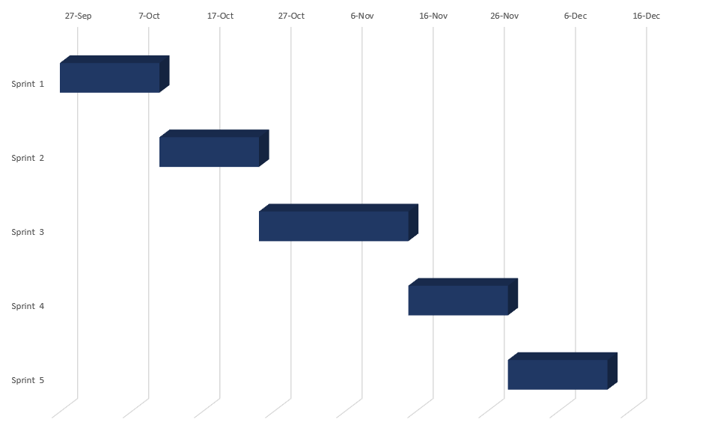

# Risk assessment

|  |  |  |  |  |  |  |
| --- | --- | --- | --- | --- | --- | --- |
| **Risks** | **Description** | **Likelihood Scale** | **Severity Scale** | **Preventive & Responsive actions** | **Identifiers** | **Responsible** |
| Risk 1 | Crossing the deadline | 1 | 5 | The team will use system development tool that allows us to plan every step and track our progress | Delays, wrong estimation, not finishing sprints, unplanned work | Michal Podgorni |
| Risk 2 | Lack of time | 2 | 4 | The team will prioritize project work over other things | Absence on meetings, not finishing tasks on time | Every team member |
| Risk 3 | Lack of experience/knowledge | 3 | 2 | The team will do their research, they will gain knowledge by focusing on the project | The team does not know how to finish a task | Every team member |
| Risk 4 | Teamwork skills | 2 | 3 | The members will work together during work meetings | Some members don’t know what others are doing, no relation between tasks | Every team member |
| Risk 5 | Wrong planning | 1 | 2 | The team will not create correct requirement and/or product backlog | Unplanned work appears | Michal Podgorni |
| Risk 6 | Not fulfilling project requirements | 1 | 4 | The team will make sure supervisors approve the idea | Some parts of the system are missing or are not possible to implement | Liviu Lesan |

# Sources of Information

*Market Data [U.S Car Rental Market]*

*Available at: https://www.autorentalnews.com/fc_resources/PDF/arnfb18-market.pdf*

*(Accessed on 20th of September 2018).*

*Auto Rental News*

*Available at: https://www.autorentalnews.com/statistics*

*(Accessed on 23rd of September 2018)*

*Car Base Innovata*

*Available at: http://www.innovata-llc.com/data/carbase/*

*(Accessed on 25th of September 2018)*